**Nikita Dhok (wj3449)**

**Stats 6610 - Homework 6**

**Part 1: Activity 1:**

* **var data = [200,150,100,90,80,70,50,20,10,1];**
* **And find the color line:**
* **var depthColors = pv.Scale.linear(0, 200)**

**Following is the Donut with above specifications:**

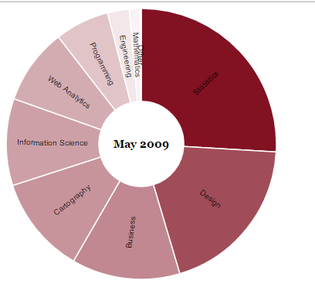

**Activity 2:**

**Stacked Bar – with label “Approval Ratings for President Obama”**

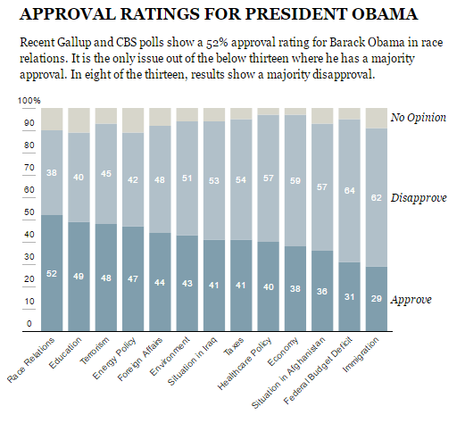

**Activity 3 :**

**Simple scatter chart**

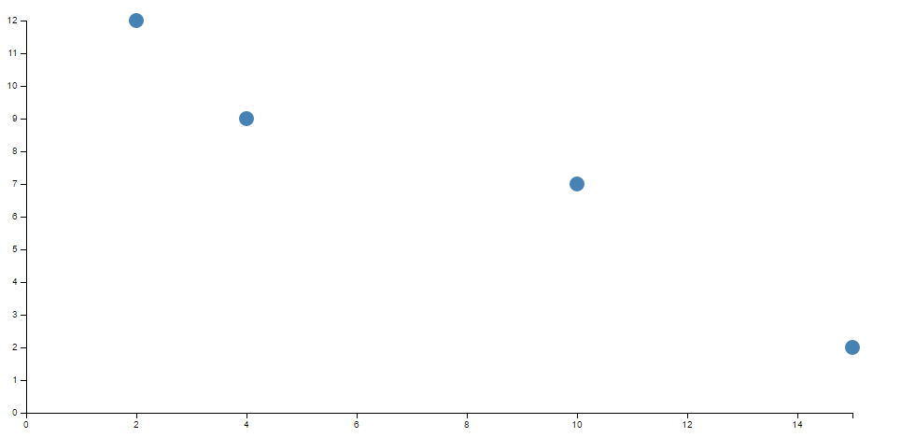

**Activity 4:**

**In R after downloading the ColorBrewer library and running the code given:**







**No, Tableau won’t use similar colors as of R, it will have different sets of colors.**

**Activity 5:**

* **Make a pie chart.**



**Screen Shot to view more clearly**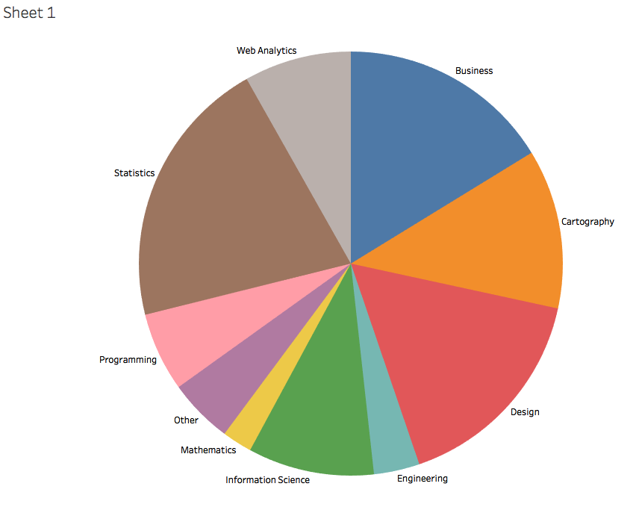

* **What do the colors looks like?**

**All the colors look different and none of them are the shades of same colors unlike the one shown in the activity 1.**

* **Change the color palette to Orange.**



**Screen Shot:**

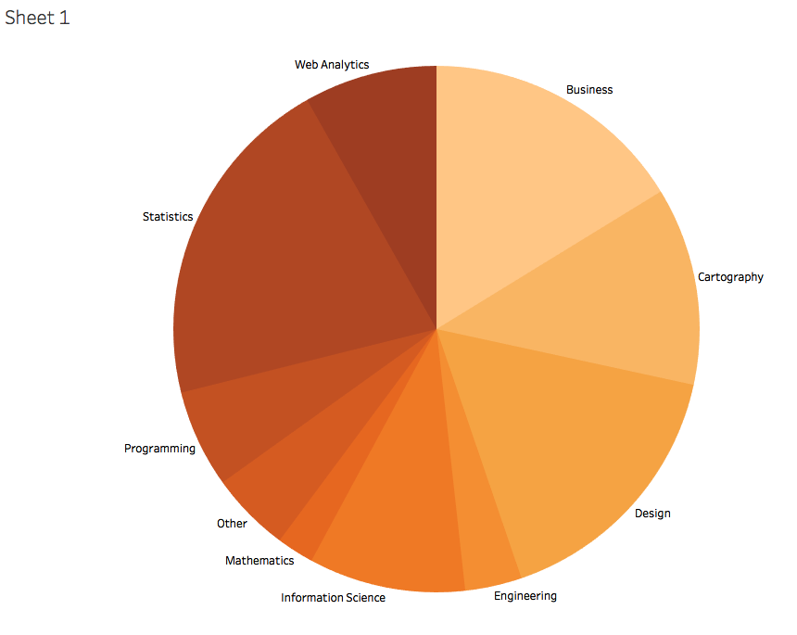

* **Change the transparency to 50%.**

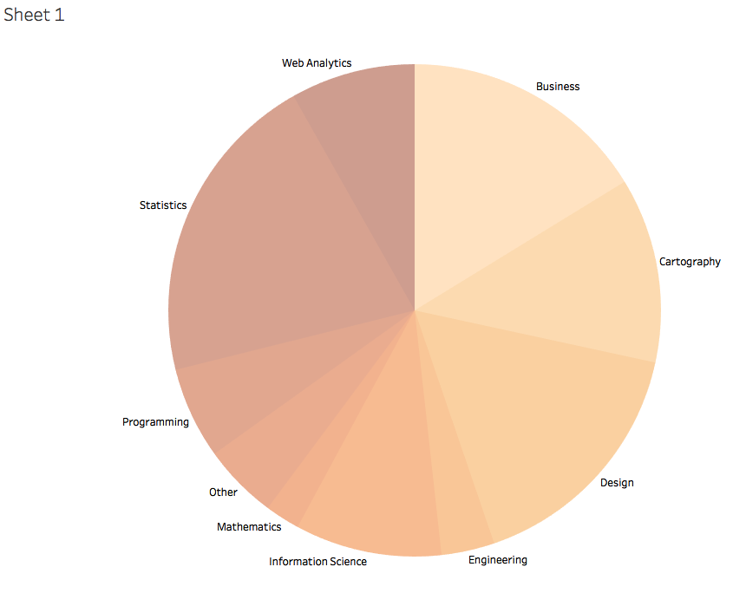

* **In Tableau, create Story and add a title and a lead in sentence.**

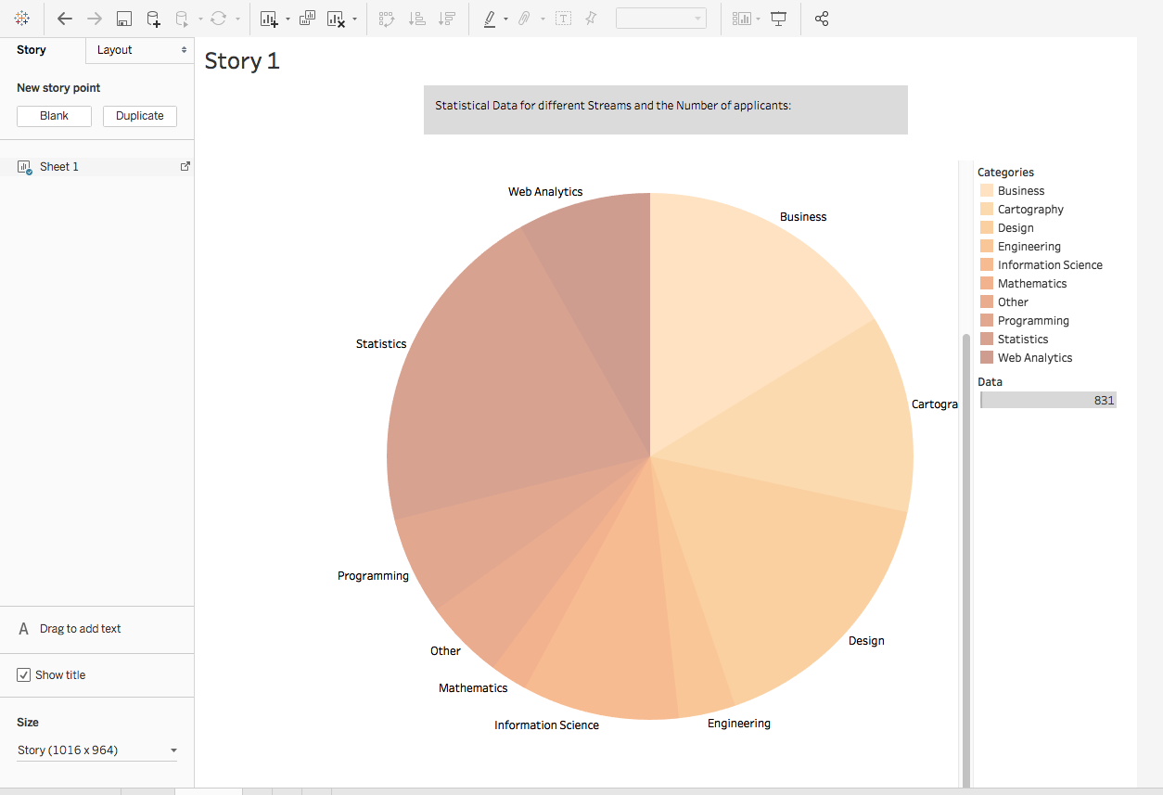

**Activity 6:**

**Make a Tree map for the post-data.txt**

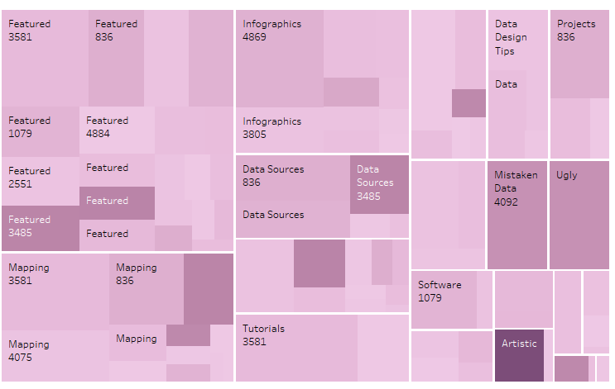

**Activity 7:**

**Make time plots for the expenditures.txt:**



**Part 2:**

**# Mosaic Plot Example**

**library(vcd)**

**mosaic(HairEyeColor, shade=TRUE, legend=TRUE)**

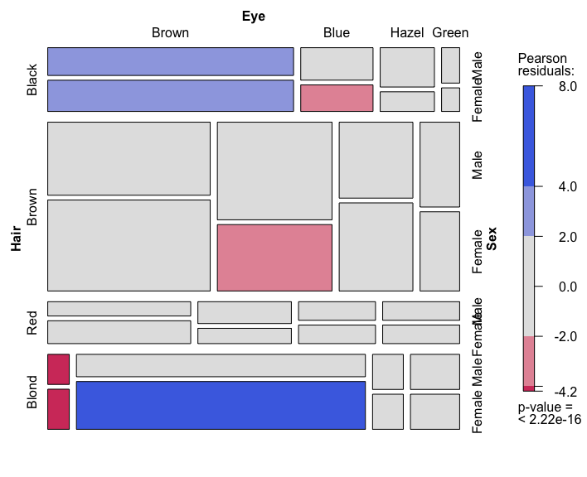

**library(hexbin)**

**x <- rnorm(10000); y <- rnorm(10000)**

**bin <- hexbin(x, y, xbins=50)**

**plot(bin, main="Hexagonal Binning")**

